Frat Finance Tracker App Update
January 5th, 2026
The following are screenshots showing the current state and usage of the app. I should be able to upload the app to the Appstore this week. The Google Play store requires that I have an android device to be able to upload apps there. I have ordered an android phone, and it should arrive soon. Once I get it set up, I can upload the app there as well.

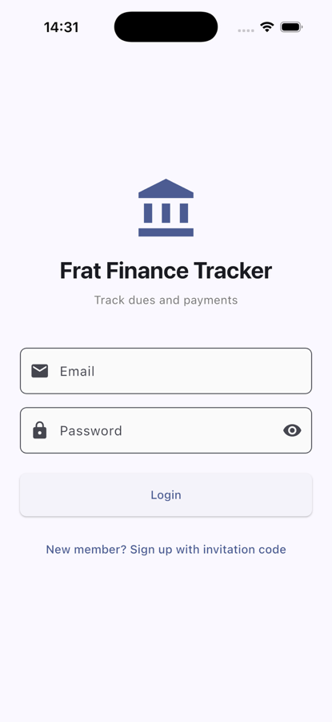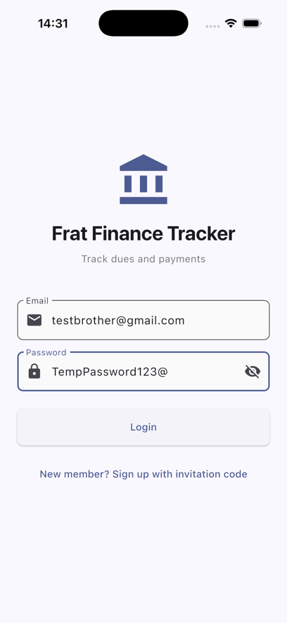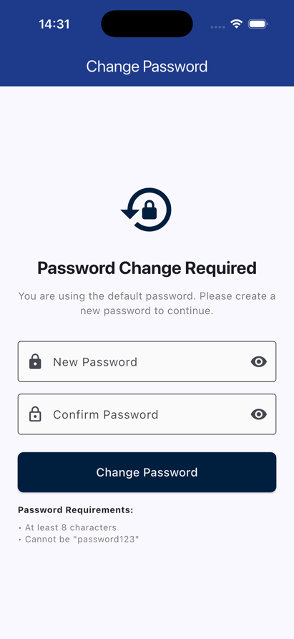
Figure 1: Login Screen. Figure 2: First Login. Figure 3: Change Password.
When users first open the app, they will see the login screen (Figure 1). After signing in with their email and temporary password (Figure 2), they will be prompted to create a secure password (Figure 3).

Main Landing Page (Brother Pages)
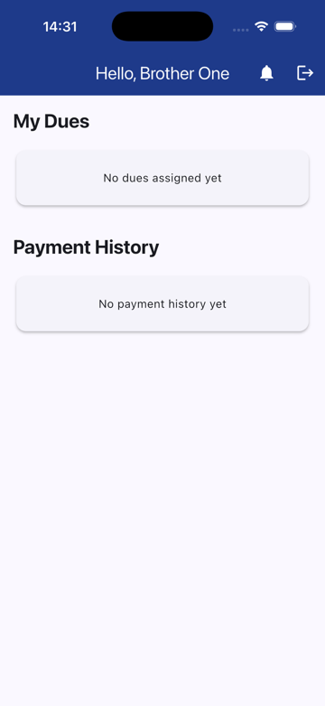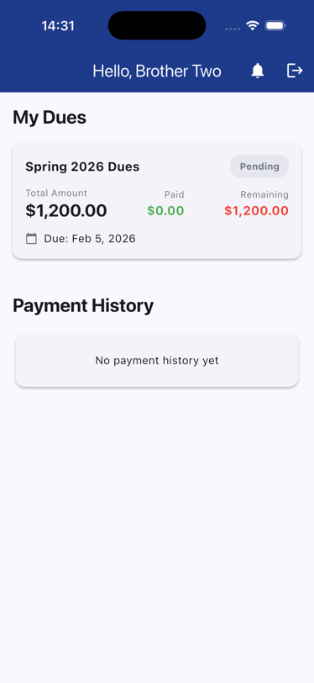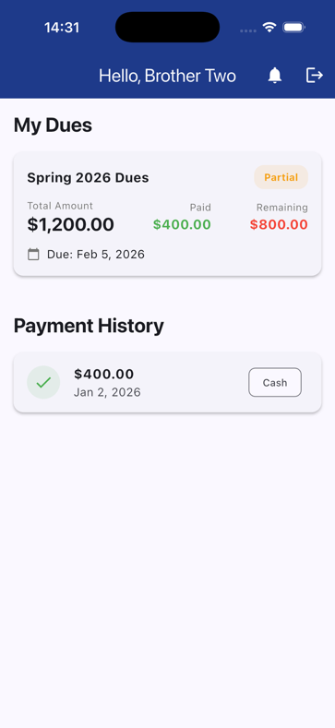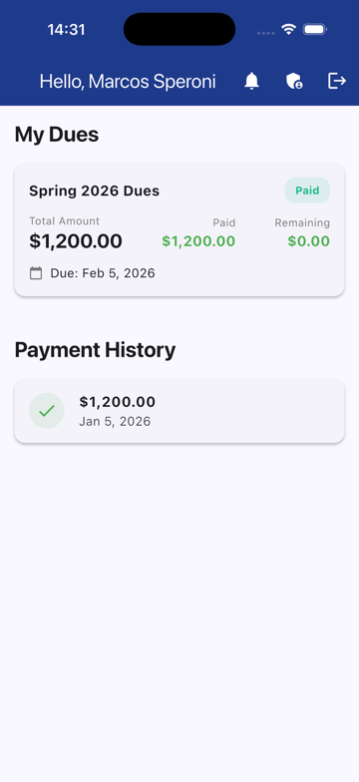
Figure 4: No dues. Figure 5: Unpaid Dues. Figure 6: Partially Paid. Figure 7: Fully Paid.
When a brother logs in to the app or opens it up after having logged in, they will see one of these 4 screens (Figures 4-7), each showing a different stage of the dues process from no dues created yet to fully paid off dues. Notice that you can see the payment history which displays the date of payment, amount, and method of payment (if recorded as seen if Figure 6).

Vice President of Finance Dashboard Pages
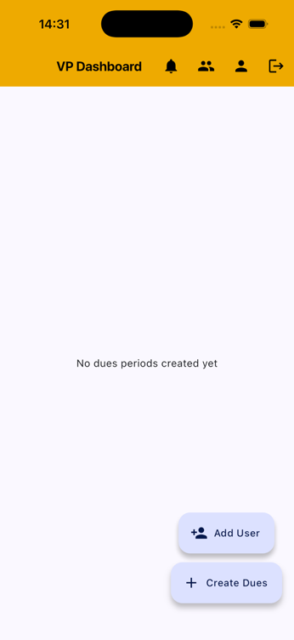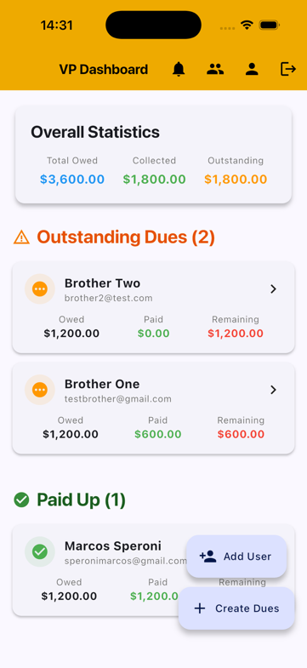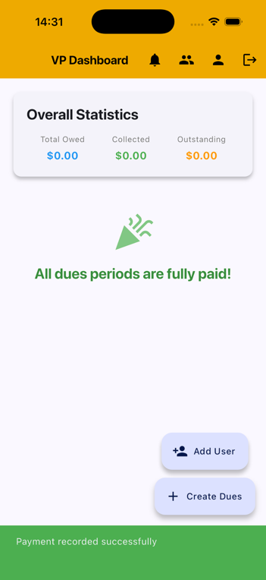
Figure 8: No dues. Figure 9: Active Dues. Figure 10: Dues Paid.
These are the pages that a VP of Finance would see when opening the app. Figures 8-10 show the status of the current dues. When dues are not fully paid off (Figure 9) brothers will be split into two groups (Outstanding Dues and Paid Up.
The stats for the dues will be shown at the top of the screen displaying Total Owed, Collected, and Outstanding (Figure 9).
As seen in Figure 10, when All dues are paid the statistics reset as there are no more active dues and a message is displayed showing all dues are fully paid.

VP of Finance Action Pages
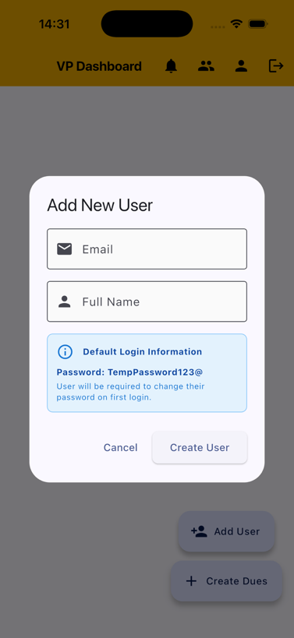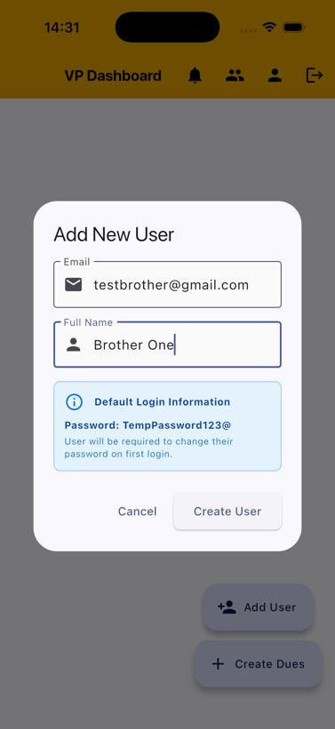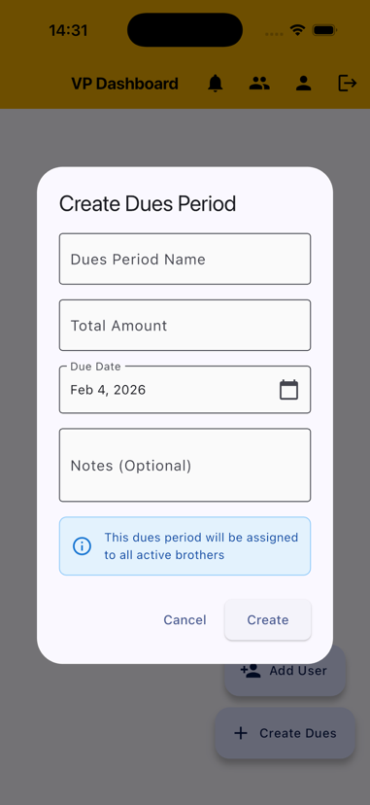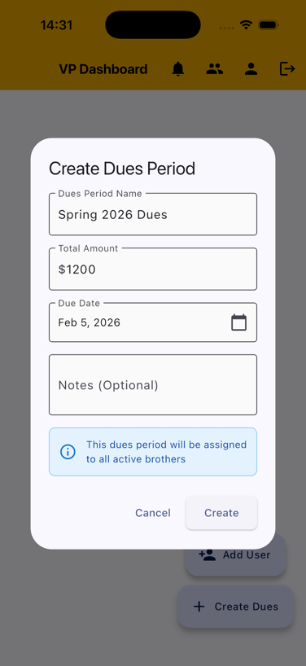
Fig. 10: Add User. Fig. 11: Example User. Fig 12. Create Dues. Fig 13. Example Dues.
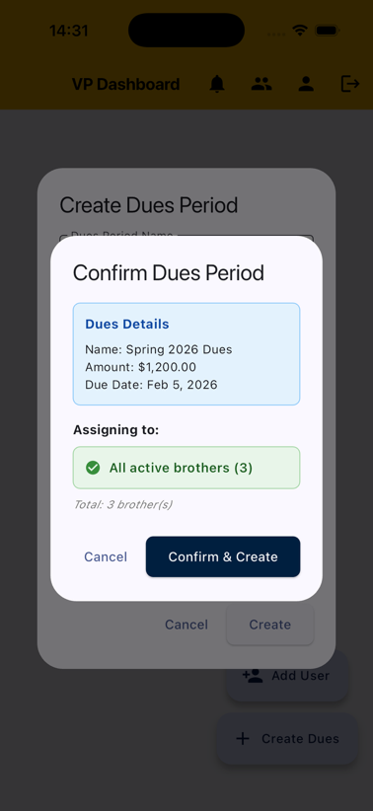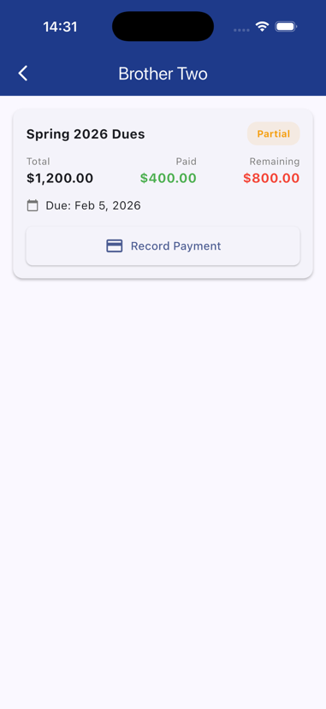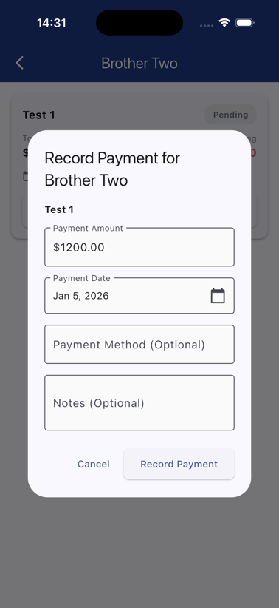
Fig. 14: Confirm Dues. Fig. 15: View of Dues. Fig 16. Record Payment.
These pages show all of the actions and screens special to the VP of Finance.
Figures 10 and 11 show how a brother will be added to the system. It also shows the temporary password, which they will use to sign in with.
Figures 12-14 show how dues will be created by the VP.
Figure 15 shows the VP of Finance’s view of a specific brothers dues. This is where the VP of Finance can record a payment. In figure 16, you can see how to record a payment. The options default to the current day and the total remaining amount of the due.
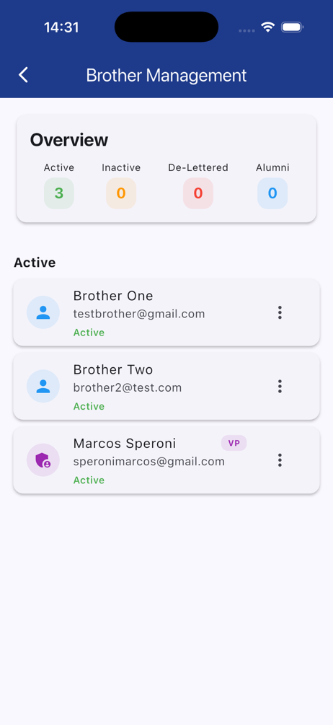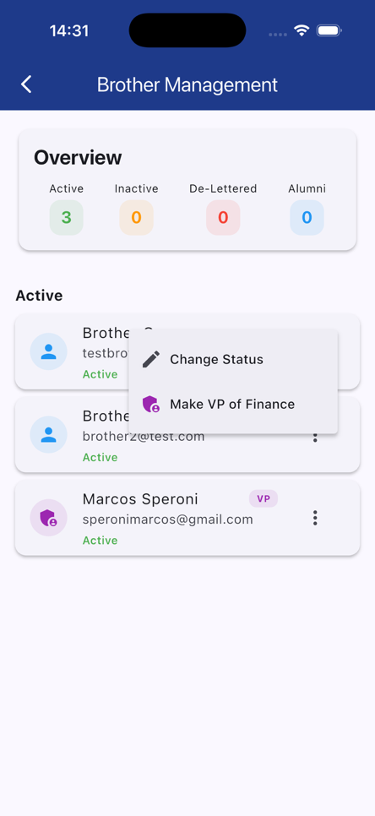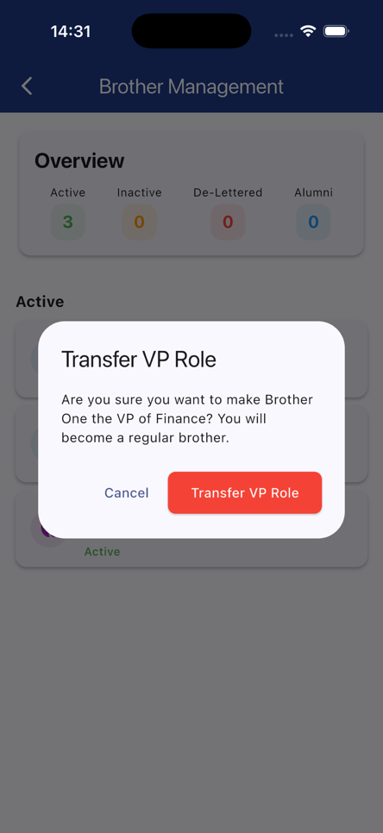
Figure 17: Brothers List Figure 18: Edit Status Figure 19: Confirm VP.
Lastly Figure 17 shows the List of Brothers (grouped by their status).
Figure 18 shows the action of how the VP of Finance changes the status of a brother as well as how they appoint a new brother to be the next VP of Finance. The action of appointing a new VP of Finance has a confirmation screen as it will remove the current VP of Finance immediately.

Working Notes:
I am currently adding the features
- Payment Plan
  - This will allow brothers to set a payment plan for themselves.
- Push Notifications
  - This will send notifications to brothers when
    - Dues are created
    - Their Payment plan has a payment date
    - Every Monday at 9 AM if their dues are still outstanding
    - They have been made VP of Finance
- And as I said earlier getting the Android side of the app going

